Text for social media posts – Pre-fieldwork
Social media card: Take action
Recently used NHS Community Mental Health services?
We are launching a survey in August to collect your valuable feedback.
If you are randomly selected, you will receive an invitation letter in the post soon.
Find out more about the survey: [INSERT TRUST PRESS RELEASE LINK FOR COMMUNITY MENTAL HEALTH SURVEY IF AVAILABLE]
Further information on Section 251: Confidential patient information - Health Research Authority
#CommunityMentalHealthSurvey

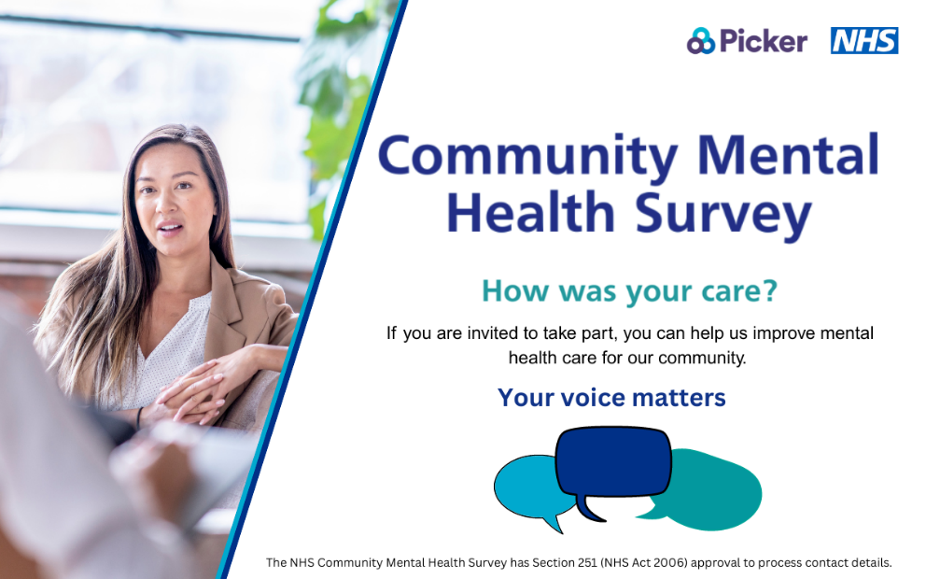

Social media card: Reminder One
We’d love to hear about your experiences. The best way for us to improve your care is by hearing from people who have recently used our services.
Last year, more than 12,000 people shared their experiences. This year, we want to hear about yours.
Please look out for the survey in the post in August 2026.
Find out more about the survey: [INSERT TRUST PRESS RELEASE LINK FOR COMMUNITY MENTAL HEALTH SURVEY IF AVAILABLE]
Further information on Section 251: Confidential patient information - Health Research Authority
#CommunityMentalHealthSurvey
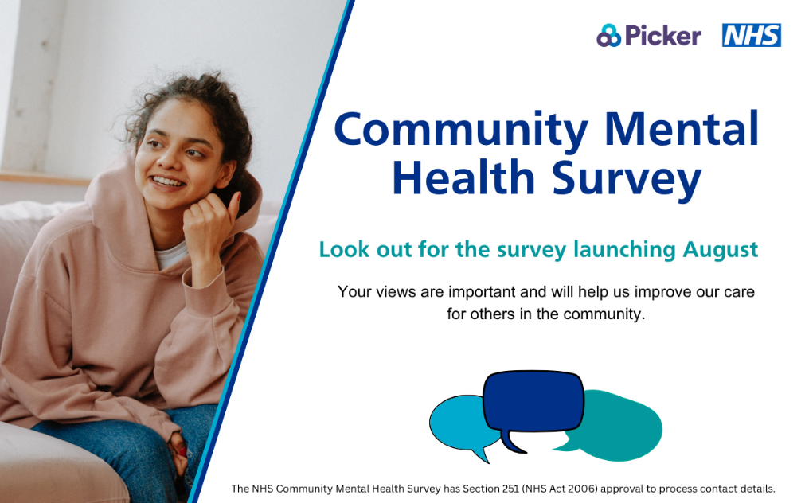

Social media card: Reminder Two
Will you take a moment to share your experience of mental health care? You may randomly be selected to take part in the 2026 #CommunityMentalHealthSurvey.
Every voice matters. Look out for your invitation in the post in August 2026.
Find out more about the survey: [INSERT TRUST PRESS RELEASE LINK FOR COMMUNITY MENTAL HEALTH SURVEY IF AVAILABLE]
Further information on Section 251: Confidential patient information - Health Research Authority
#CommunityMentalHealthSurvey
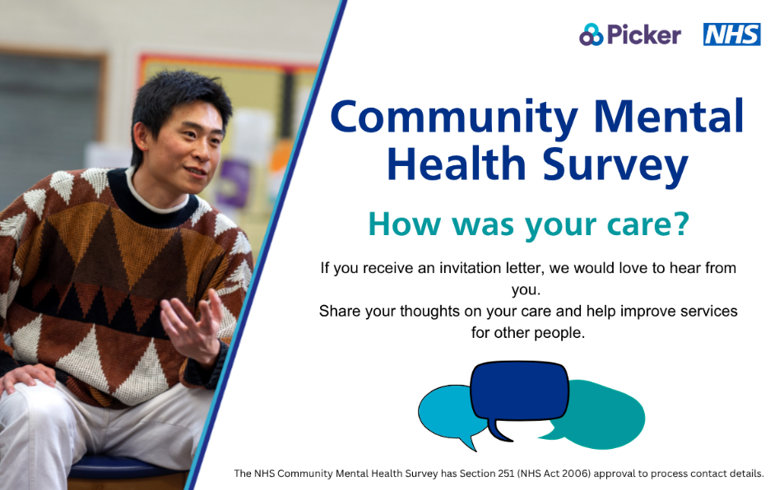

Social media card: Reminder Three
Have you used community mental health services in April and May 2026? In August we are launching a survey to collect your feedback on your NHS mental health care.
If you are selected to take part, you’ll receive an invitation letter in August 2026.
We are listening closely to what you have to say, your response will help us improve mental health care for you and our community.
Find out more about the survey: [INSERT TRUST PRESS RELEASE LINK FOR COMMUNITY MENTAL HEALTH SURVEY IF AVAILABLE]
Further information on Section 251: Confidential patient information - Health Research Authority
#CommunityMentalHealthSurvey
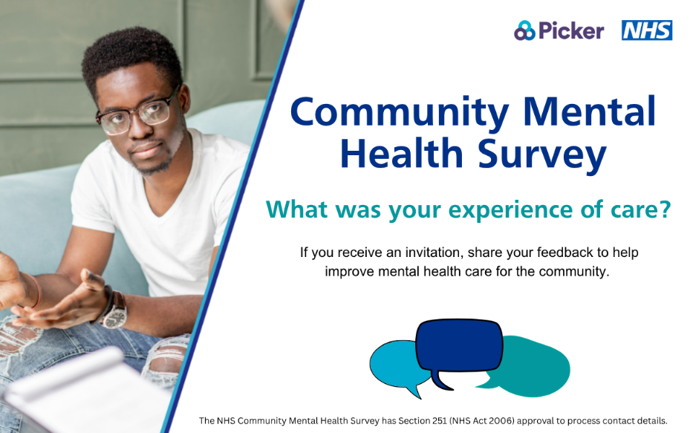

Text for social media posts – during fieldwork
Social media card: Take action
Recently used NHS Community Mental Health services? You might be invited to take party in this year’s #CommunityMentalHealthSurvey.
Look out for a letter in the post and a text reminder too!
Your valuable feedback will help us improve the quality of our care and other people’s experience.
Find out more about the survey: [INSERT TRUST PRESS RELEASE LINK FOR COMMUNITY MENTAL HEALTH SURVEY IF AVAILABLE]
Further information on Section 251: Confidential patient information - Health Research Authority
#CommunityMentalHealthSurvey

Social media card: Reminder One
Last year, more than 12,000 people shared their experiences. Now, you can make a difference.
If you have used community mental health services in April and May 2026, you could be randomly selected to take part in the #CommunityMentalHealthSurvey.
We’d love to hear about your experiences. The best way for us to improve your care is by hearing from people who have recently used our services
Find out more about the survey: [INSERT TRUST PRESS RELEASE LINK FOR COMMUNITY MENTAL HEALTH SURVEY IF AVAILABLE]
Further information on Section 251: Confidential patient information - Health Research Authority
#CommunityMentalHealthSurvey
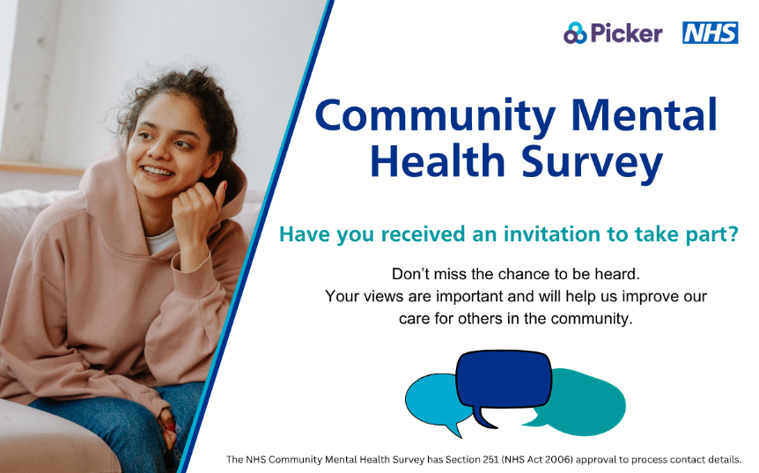

Social media card: Reminder Two
Every voice matters. Will you take a moment to share your experience of mental health care?
If you have recently used community mental health services, you may be invited to take part in this year’s #CommunityMentalHealthSurvey.
Look out for a letter in the post and a text message with a survey link to share your experience.
Find out more about the survey: [INSERT TRUST PRESS RELEASE LINK FOR COMMUNITY MENTAL HEALTH SURVEY IF AVAILABLE]
Further information on Section 251: Confidential patient information - Health Research Authority
#CommunityMentalHealthSurvey
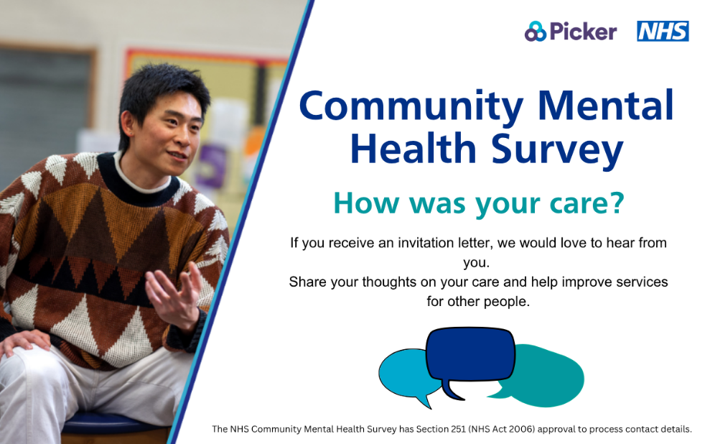

Social media card: Reminder Three
Recently used NHS Community Mental Health services?
This is your chance to give feedback on your NHS mental health care.
If you are selected to take part, you will receive an invitation letter for the #CommunityMentalHealthSurvey in the post and a text message reminder with a survey link to share your experience.
Find out more about the survey: [INSERT TRUST PRESS RELEASE LINK FOR COMMUNITY MENTAL HEALTH SURVEY IF AVAILABLE]
Further information on Section 251: Confidential patient information - Health Research Authority
#CommunityMentalHealthSurvey
